# System Analysis & Design

1. **Definition of system analysis and design.**

Ans: **System analysis:** Is conducted for the purpose of studying a system or its parts in order to identify its objectives. It is a problem-solving technique that improves the system and ensures that all the components of the system work efficiently to accomplish their purpose.

**System Design:** It is a process of planning a new business system or replacing an existing system by defining its components or modules to satisfy the specific requirements. Before planning, you need to understand the old system thoroughly and determine how computers can best be used in order to operate efficiently.

1. **Constraints of a system, Properties of a system, Elements of a system**

Ans:

**Constraints of a system**: A system must have three basic constraints −

* A system must have some structure and behavior which is designed to achieve a predefined objective.
* Interconnectivity and interdependence must exist among the system components.
* The objectives of the organization have a higher priority than the objectives of its subsystems.

**Properties of a system:** A system has several key properties:

* Organization: This refers to the structured arrangement of components to achieve specific goals.
* Interaction: It describes how components operate together. For instance, different departments within an organization must interact for smooth functioning.
* Interdependence: Components rely on each other for proper operation. They are coordinated and linked according to a plan, with outputs from one part often serving as inputs for another.
* Integration: This involves connecting system components. Even if each part serves a unique function, they work together seamlessly within the system.
* Central Objective: A system must have a clear central objective, which may be either stated or implied.

**Elements of a system:**  A system has several key elements:

1. Outputs and Inputs:

* The system generates useful outputs for users from incoming information.
* Inputs are data entering the system.
* Output is the processed result.

1. Processor(s):

* The processor transforms input into output.
* It's the operational part of the system, adapting input based on output needs.
* Processing adapts with changing output specifications, sometimes requiring input adjustments.

1. Control:

* Controls direct system activities.
* It's the decision-making subsystem overseeing input, processing, and output.
* The Operating System and software manage system behavior, adjusting input per output requirements.

1. Feedback:

* Feedback regulates system dynamics.
* Positive feedback boosts system performance; negative feedback informs action.

1. Environment:

* The environment is the broader system in which an organization operates.
* It influences system function, including vendors and competitors.
* Environment sets operational constraints on business performance.

1. Boundaries and Interface:

* Systems are defined by boundaries, outlining components and interactions.
* Each system's boundaries define its control and influence.
* Understanding boundaries is critical for designing effective system interfaces.

1. **What is system. Types of system.**

Ans: The word System is derived from Greek word Systema, which means an organized relationship between any set of components to achieve some common cause or objective.

The systems can be divided into the following types:

**Physical or Abstract Systems:**

* Physical systems are tangible and can be touched or felt.
* They can be static (like desks and chairs) or dynamic (like programmed computers).
* Abstract systems are non-physical, like formulas or models.

**Open or Closed Systems:**

* Open systems interact with the environment, receiving inputs and delivering outputs.
* Closed systems are isolated from the environment, although fully closed systems are rare.

**Adaptive and Non-Adaptive Systems**:

* Adaptive systems respond to environmental changes to improve performance (e.g., humans).
* Non-adaptive systems do not respond to the environment (e.g., machines).

**Permanent or Temporary Systems:**

* Permanent systems persist (অবিরত) long-term (e.g., business policies).
* Temporary systems are set up for a specific time and then dismantled (e.g., event Dj systems).

**Natural and Manufactured Systems:**

* Natural systems are created by nature (e.g., the solar system).
* Manufactured systems are man-made (e.g., rockets, dams).

**Deterministic or Probabilistic Systems:**

* Deterministic systems operate predictably (e.g., chemical reactions).
* Probabilistic systems exhibit uncertain behavior (e.g., weather forecasting).

**Social, Human-Machine, Machine Systems**:

Social systems involve people (e.g., social clubs).

* Human-machine systems combine human and machine interactions (e.g., computer programming).
* Machine systems operate without human interference (e.g., autonomous robots).

**Man-Made Information Systems:**

* Interconnected information resources managed for an organization.
* Includes hardware, software, communication, data, and applications.
* Types include formal (top-down information flow), informal (employee-based problem-solving), and computer-based systems (dependent on computers for managing applications).

1. **Identify & analysis a real time app on the following category:**
2. **System type b) System model & c) Category of information**

Ans: The real-life app that we will analyze is Instagram. We will analyze it based on system type, model and category of information.

Instagram falls on the following system types:

* Open and closed system: Instagram interacts with environment and also adapts to changes.
* Adaptive system: Instagram responds to the changes in the environment to improve its performance and to survive
* Deterministic system: Instagram operates in a predictable manner. For example, if an Instagram post gest more likes, then it will be shown to more people.
* Social system: Instagram is a social system because it is made up of the people using it to share photos.

Unlike system types, Instagram only falls on the system model and that is dynamic system model.

* People’s post are inputs that extends the system.
* People’s reaction’s share and comments dynamically determines the amount of other users will see the posts.
* Trends, popularity and other functions are also dynamically determined by the user’s engagement.

Now in the aspect of category of information Instagram primarily falls under the category of operation information. In the case of Instagram, operational information includes user interactions such as posts, photos, messaging other users and managing account settings. This information is crucial for the functioning of the platform on a daily basis and forms the core of its operational activities.

While Instagram may also generate some managerial information related to user engagement metrics content moderation and platform usage patterns, the bulk of the information processed and managed by the system falls under the operational category.

1. **Who is a system analysis. Main roles of a analysts, attributes of a system analyst, project analysis.**

Ans: The system analyst is a person who is thoroughly aware of the system and guides the system development project by giving proper directions. He is an expert having technical and interpersonal skills to carry out development tasks required at each phase.

Main roles of a system analyst are:

* Understanding user requirements through fact-finding techniques.
* Prioritizing requirements based on user consensus.
* Gathering information and user opinions.
* Analyzing and evaluating to create user-friendly systems.
* Proposing flexible solutions, selecting the best one, and assessing costs and benefits.
* Creating clear specifications for users and programmers.
* Designing modular logical systems.
* Planning periodic evaluations and system modifications as needed.

Attributes (Skill) of a system analyst:

**Interpersonal Skills**

* Interface with users and programmer.
* Facilitate groups and lead smaller teams.
* Managing expectations.
* Good understanding, communication, selling and teaching abilities.
* Motivator having the confidence to solve queries.

**Analytical Skills**

* System study and organizational knowledge
* Problem identification, problem analysis, and problem solving
* Sound commonsense
* Ability to access trade-off
* Curiosity to learn about new organization

**Management Skills**

* Understand users’ jargon and practices.
* Resource & project management.
* Change & risk management.
* Understand the management functions thoroughly.

**Technical Skills**

* Knowledge of computers and software.
* Keep abreast of modern development.
* Know of system design tools.
* Breadth knowledge about new technologies.

1. **What is Feasibility study. Types of feasibility.**

Ans: Feasibility Study can be considered as preliminary investigation that helps the management to take decision about whether study of system should be feasible for development or not.

* It identifies the possibility of improving an existing system, developing a new system, and produce refined estimates for further development of system.
* It is used to obtain the outline of the problem and decide whether feasible or appropriate solution exists or not.
* The main objective of a feasibility study is to acquire problem scope instead of solving the problem.

Types of feasibility study:

**Economic Feasibility:**

* Evaluates system effectiveness using cost/benefit analysis.
* Aims to estimate economic requirements before investing funds.
* Prefers alternatives maximizing organization's net worth with earliest, highest return and lowest risk.

**Technical Feasibility:**

* Investigates if implementation alternatives are technically feasible.
* Analyzes existing technology support and potential upgrades.
* Ensures candidate system can adequately support technical enhancements.

**Operational Feasibility:**

* Determines if system operates effectively post-development.
* Ensures management supports proposed system and its functionality fits current organizational environment.
* Analyzes user acceptance and potential impact on business methods.

**Behavioral Feasibility:**

* Evaluates user attitude towards new system development.
* Helps assess need for training or changes in employee roles.

**Schedule Feasibility:**

* Ensures project completion within given time constraints.
* Verifies project deadlines are reasonable.

1. **Suppose you are a system analyst. A project Is knocked at your door. You are selected for this project. Draw a working activity diagram for this project according to SDLC.**
2. **Draw the working activity as per SDLC**

**Ans:** I am a system analyst. A project knocked on my door, and I am selected for that project. My working activity for my project will start from the bellow flowchart.

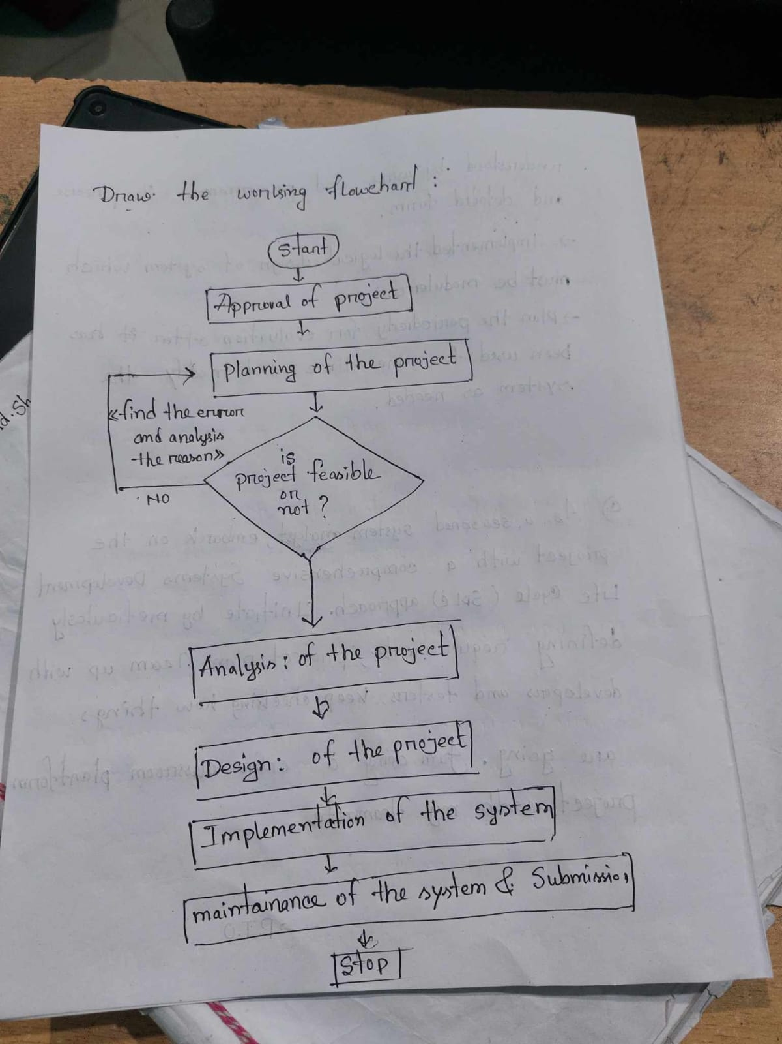

My working activities as per the phase of SDLC:

1. Feasibility Study: Defines problem scope, outlines objectives, considers threats and constraints, and creates a feasibility report.
2. Analysis and Specification: Gathers and validates requirements, considers user needs, and produces a comprehensive Software Requirements Specification (SRS) document.
3. System Design: Translates SRS into detailed implementation blueprint covering application, network, databases, interfaces, and contingency plans.
4. Implementation: Codes modules, conducts testing for bug detection, and logs errors through a planned approach.
5. Maintenance/Support: Provides ongoing user support, addresses evolving needs, resolves bugs, and implements changes post-testing.
6. **What is SDLC? Write the phases of SDLC.**

Ans: Systems Development Life Cycle is a systematic approach which explicitly breaks down the work into phases that are required to implement either new or modified Information System.

Phases of SDLC are:

1. **Feasibility Study:**

* Define project scope, goals, and constraints.
* Assess feasibility and create a project schedule.
* Consider threats, integration, and security.
* Deliver a feasibility report.

2. **Analysis and Specification:**

* Gather and validate information.
* Define system requirements and prototypes.
* Evaluate and prioritize requirements.
* Consider user needs and system goals.
* Create a Software Requirement Specification (SRS).

**3. System Design:**

* Design application, network, databases, interfaces, etc.
* Translate SRS into a detailed implementation plan.
* Develop contingency, training, maintenance, and operations plans.
* Review and finalize the design.
* Deliver a design document.

**4. Implementation:**

* Code the system based on the design.
* Integrate modules and perform unit testing.
* Execute test plan and document detected errors.
* Integrate and install the system.

5. **Maintenance/Support:**

* Provide user support (phone, on-site, etc.).
* Implement changes and new requirements.
* Address residual errors and issues.
* Support duration varies based on system size and complexity.